HOSPITAL MANAGEMENT SYSTEM
MAMJI HOSPITAL

SOFTWARE ENGINEERING PRINCIPLES

DATE: - 31-12-2024

GROUP MEMBERS
SUKAINA SHOAIB 23FA-049-SE
HABIBA AZFAR 23FA-024-SE
SYED AZHAR 23FA-001-SE
ABDULLAH DANISH 23FA-016-SE
COURSE INSTRUCTOR
INSTRUCTOR NAME:- SIR USMAN WAHEED
PROJECT MANAGER: - DR SADAF

Usman Institute of Technology University


HOSPITAL MANAGEMENT SYSTEM
(SUKAINA SHOAIB , HABIBA AZFAR ,SYED AZHAR , ABDULLAH DANISH )

ABSTRACT / Executive Summary

The problem addressed by the Hospital Management System (HMS) is the inefficiency and complexity in managing patient appointments, medical tests, treatment records, and doctor-patient interactions in traditional hospital management practices. These issues often lead to delays, errors in patient care, and administrative burdens on hospital staff.
The importance of addressing these challenges is critical, as a streamlined system can significantly enhance patient satisfaction, improve operational efficiency, and reduce errors. This can ultimately lead to better healthcare delivery, timely treatment, and improved outcomes for patients.
Several solutions were considered to address the problem:
- A manual, paper-based system that involves physical records and appointment scheduling.
- A fully automated system, with extensive integration of electronic health records, medical tests, and appointment management.
The solution selected is a hybrid approach with a portal for both patients and doctors. Patients can easily book appointments, schedule tests, access their medical reports, and view treatment plans. Doctors, on the other hand, can see their daily appointments and provide treatment instructions through the patient’s unique ID, ensuring personalized care.
This solution was evaluated on ease of use, time efficiency, and data accuracy. Initial feedback suggests that the system has significantly reduced the administrative workload, minimized errors, and improved communication between patients and healthcare providers.
Suggestions for further work include:
- Integrating more advanced features:- telemedicine capabilities for remote consultations.
- Expanding the system:- to include integration with pharmacies and insurance providers for a more comprehensive healthcare experience.
- Implementing AI-based:- diagnostic tools to assist doctors in treatment decisions.
This ongoing development will ensure the system remains adaptable and scalable, meeting the evolving needs of healthcare providers and patients.

Table of Contents
INTRODUCTION AND OVERVIEW: 8
BACKGROUND 9
AIM AND STATEMENT OF PROBLEM 9
METHODS, ASSUMPTIONS, AND PROCEDURES 10
AVAILABLE RELEVANT SOLUTIONS AND EVALUATION 11
ANALYSIS AND DESIGN 12
FOR J = 1 TO NO. OF USE CASES 12
NEXT 12
USE CASE NARRATION: 75
SUPPORT 79
CONCLUSIONS AND SUGGESTIONS FOR FUTURE WORK 81
REFERENCES 82
CONFERENCE EXAMPLE 82
BOOK EXAMPLE 82
WEBSITE REFERENCE 82
APPENDICES SHOULD APPEAR AFTER THE LIST OF REFERENCES 83
LIST OF SYMBOLS 84
GLOSSARY 86
INDEX 88

LIST OF FIGURES

Figure No. | Description | Page No.
1.1 | Swim Lane Diagram for Hospital Management System: | 14
2.1 | Context Diagram for Hospital Management System | 16
3.1 | Actor Use-case Diagram of Hospital Management System  Use Case Diagram for Patient  Use Case Diagram for Reception  Use Case Diagram for Doctor  Use Case Diagram for Physiotherapist  Use Case Diagram for laboratory  Use Case Diagram for Radiology | 18-22
4.1 | Complete Object Diagram of Hospital Management System: | 35
5.1 | Sequence Diagram of Hospital Management System | 36
6.1  6.2  6.3  6.4  6.5  6.6 | Input Design Prototype of Login  Input Design Prototype of sign up  Sequence Diagram of Book an Appointment  Sequence Diagram of Book an Appointment  Input Design Prototype of Appointment Detail  Input Design Prototype of Appointment Detail | 37-42
7.1  7.2  7.3  7.4  7.5  7.6 | Sequence Diagram of lab test  Input Design Prototype of lab test  Input Design Prototype of Lab test detail  Input Design Prototype of Lab Test Report  Output Design Prototype of Lab Test  Input Design Prototype of view treatment | 43-49
8.1  8.2  8.3 | Input Design Prototype of view Appointment  Input Design Prototype of Treatment  Output Design Prototype of Treatment | 51-53
9.1  9.2 | Input Design Prototype of view Appointment  Output Design Prototype of Treatment | 54-55
10.1 | Complete Class Diagram of Hospital Management System | 56
11.1 | DataBase Diagram of Hospital Management System | 57
12.1 | Deployment Component Diagram of Hospital Management System | 65

LIST OF TABLE

Table No. | Description | Page No.
01 | Actor Use case Table | 58
02 | Report List Table | 59-61
03 | List of Symbols | 76-77
04 | Glossary | 78-79

ACKNOWLEDGMENTS

We would like to thank the Almighty God who has enabled us to complete this course, for the courage, finances, and wisdom, your name be Exalted on high.
I would like to express my sincere thanks to the Vice Chancellor of the Institute, Dr.Vali , for providing the necessary resources and facilities that enabled me to carry out this project effectively.
I extend my heartfelt gratitude to my instructor, Usman Waheed, whose invaluable guidance, insightful suggestions, and constant support were instrumental throughout this journey. Their expertise and encouragement motivated me to explore new dimensions and overcome challenges during the course of the project.

We would like to thank MAMJI HOSPITAL for making this project possible for us and for providing all the necessary information, evidences related to the project. And thank you for giving us precious time from your busy schedule.

Finally, I would like to acknowledge my peers, family, and friends for their unwavering support and encouragement, which provided me with the strength and confidence to complete this project.
Thank you all for being part of this rewarding experience.

HOSPITAL MANAGEMENT SYSTEM
(SUKAINA SHOAIB , HABIBA AZFAR , SYED AZHAR , ABDULLAH DANISH )

INTRODUCTION AND OVERVIEW:

Executive Summary: Hospital Management System
The problem addressed by the Hospital Management System (HMS) is the inefficiency and complexity in managing patient appointments, medical tests, treatment records, and doctor-patient interactions in traditional hospital management practices. These issues often lead to delays, errors in patient care, and administrative burdens on hospital staff.
The importance of addressing these challenges is critical, as a streamlined system can significantly enhance patient satisfaction, improve operational efficiency, and reduce errors. This can ultimately lead to better healthcare delivery, timely treatment, and improved outcomes for patients.
Several solutions were considered to address the problem:
- A manual, paper-based system that involves physical records and appointment scheduling.
- A fully automated system, with extensive integration of electronic health records, medical tests, and appointment management.

Mamji Hospital, founded in 1973, is a well-known healthcare institution located in Karachi, Pakistan. The hospital was established with the aim of providing affordable and quality healthcare services to the people of Karachi. It was founded by Dr. Haji Shamsuddin, who envisioned a hospital that would cater to the diverse medical needs of the community, offering a wide range of services, from emergency care to specialized treatments.
The analysis of this research problem raises several issues, such as how to effectively monitor and control the operation of boilers, how to effectively analyze data from boilers, and how to develop advanced algorithms that can optimize boiler operations.

The solution selected is a hybrid approach with a portal for both patients and doctors. Patients can easily book appointments, schedule tests, access their medical reports, and view treatment plans. Doctors, on the other hand, can see their daily appointments and provide treatment instructions through the patient’s unique ID, ensuring personalized care.
This solution was evaluated on ease of use, time efficiency, and data accuracy. Initial feedback suggests that the system has significantly reduced the administrative workload, minimized errors, and improved communication between patients and healthcare providers.
Suggestions for further work include:
- Integrating more advanced features such as telemedicine capabilities for remote consultations.
- Expanding the system to include integration with pharmacies and insurance providers for a more comprehensive healthcare experience.
- Implementing AI-based diagnostic tools to assist doctors in treatment decisions.
This ongoing development will ensure the system remains adaptable and scalable, meeting the evolving needs of healthcare providers and patients.

BACKGROUND

In the existing Hospital Management System (HMS), real-time communication is crucial for smooth operations. Whenever there is an issue, the system automatically sends alerts to the concerned personnel, allowing quick identification and resolution of problems. This proactive communication ensures that healthcare providers can promptly address issues before they escalate, improving patient care and operational efficiency.
However, like any system, there are some challenges that need to be addressed:

• Difficulty in managing patient appointments and test bookings in real-time, which could result in scheduling conflicts or delays in patient care.
• Inaccurate data handling, leading to errors in patient records, incorrect test results, or miscommunication between doctors and patients.
• Complexity of the user interface, which may be challenging for both healthcare providers and patients to navigate, potentially leading to inefficient use of the system.

The Hospital Management System aims to streamline these processes by offering easy access to real-time data, ensuring that both patients and medical staff can quickly address issues, improving overall care quality and hospital efficiency.

AIM AND STATEMENT OF PROBLEM

The aim of this project is to develop an advanced Hospital Management System (HMS) that enhances patient care, streamlines hospital operations, and improves the efficiency of healthcare delivery.
The scope of the project includes the development of a comprehensive system that can be integrated into existing hospital workflows. The system will cater to a wide range of functionalities, including patient appointment scheduling, test bookings, report access, and treatment records. It will also enable doctors to manage their daily appointments and provide treatment updates for patients efficiently.
To address these challenges, the project will utilize advanced software solutions and data management techniques to ensure real-time communication, accuracy, and ease of use for all stakeholders. The system will be designed to handle the unique requirements of different healthcare facilities, ensuring scalability and adaptability.
It is important to note that the nature and scope of this project may evolve based on the specific requirements and feedback from healthcare providers and patients, ensuring that the system remains relevant and effective in addressing modern healthcare needs.

METHODS, ASSUMPTIONS, AND PROCEDURES

In summary, the methodology used to analyze and design a boiler management system typically involves several stages, including requirements gathering, system design, implementation, testing and validation, and deployment and maintenance. Alternative methodologies, such as Agile, may also be considered depending on the specific requirements of the project.
The methodology for analyzing and designing a Hospital Management System (HMS) involves several critical stages to ensure the system meets user needs and operates effectively. These stages include:
- Identifying and Defining the Problem
  - Understanding the current challenges in hospital operations, such as inefficiencies in patient appointment scheduling, delays in test result dissemination, and difficulty managing treatment records.
  - Gathering input from stakeholders, including doctors, patients, and administrative to define the scope and objectives of the system.
- System Design
  - Developing a detailed blueprint of the system, including its architecture, components, and user interfaces.
  - Identifying key functionalities, such as patient registration, appointment booking, report viewing, and treatment plan management.
  - Designing interfaces for real-time communication between doctors, patients, and other hospital departments.
- Implementation and Testing
  - Building the system using modern programming languages and frameworks..
  - Refining the system based on feedback from stakeholders during testing phases.
- Deployment and Maintenance
  - Deploying the system in the hospital environment, ensuring minimal disruption to existing workflows.
  - Providing training sessions for staff and end-users to familiarize them with the system.
Assumptions
- The system will be compatible with existing hospital infrastructure and workflows.
- Data privacy and security measures will be implemented to comply with healthcare regulations.
Procedures
- Employing iterative development methods, such as Agile, to allow flexibility and accommodate evolving requirements.
In summary, the methodology for designing the HMS includes a systematic approach from problem identification to deployment and maintenance. Flexibility in methodology, such as adopting Agile practices, may be considered based on specific project needs.

AVAILABLE RELEVANT SOLUTIONS AND EVALUATION

The specific solution will depend on the facility's requirements and constraints and the features needed.
Several solutions are available for managing hospital operations efficiently, depending on the specific needs and constraints of the healthcare facility. Below are some common solutions and their evaluation:
- Patient Portal Solutions
  - Description: Provides patients with a secure platform to book appointments, access test results, and view treatment plans.
  - Advantages: Improves patient convenience, reduces administrative burden, and enhances transparency.
  - Limitations: Requires patients to have basic technological literacy and access to the internet.

- Web-Based Interfaces
  - Description: Provides an intuitive, browser-based interface for both patients and staff to interact with the system.
  - Advantages: Offers ease of use and accessibility across devices, including smartphones and tablets.
  - Limitations: Potential for system downtime due to internet issues.

- Integrated Mobile Applications
  - Description: Mobile apps that allow patients and doctors to interact with the hospital management system conveniently.
  - Advantages: Enhances accessibility for users on the go and offers features like appointment reminders and push notifications.
  - Limitations: Requires regular updates and compatibility across different devices and operating systems.

ANALYSIS AND DESIGN

Thoroughly support and defend the solution that is proposed. Discuss technique that was used in analysis and design. First provide a summary that what is covered in analysis and design section, and is the purpose of each activity that is implemented or documented. A brief discussion on sequence of activities, with their deliverables and documentation. All diagrams should follow UML notations and must be developed in any UML case tool.

Note: you have to organize deliverables listed below

Business process workflow
Business document workflow
Context Diagram
System diagram
Object diagram (complete)
Actor usecase diagram
Actor usecase table
Report list Table
Report detailed list

For j = 1 to no. of use cases

Analysis Use case documentation (A)
Object diagram
Design Use case Documentation (D)
Sequence Diagram (D)
Input Design Prototype (D)
Output Design Prototype (D)
Class diagram (D) with control and interface classes

Next
Class Diagram (with all attributes and behaviors)
Database Diagram

Note:
All diagrams must be developed in VISIO, or STAR UML and must follow standard notations

All diagrams must be numbered, labeled, refered and explained,

In Object diagram each object name be preamble with player initial (Pr, Tr, TrLI, I, SI, OA),e.g Pr-Customer, and attributes of transaction Pattern in Bold and aboutme in italic.

Swim Lane Diagram for Hospital Management System:
The swim lane diagram was used to describe the business and its operational step-by-step workflows of components in the HMS.

Figure1.1 – Swim Lane Diagram for Hospital Management System:

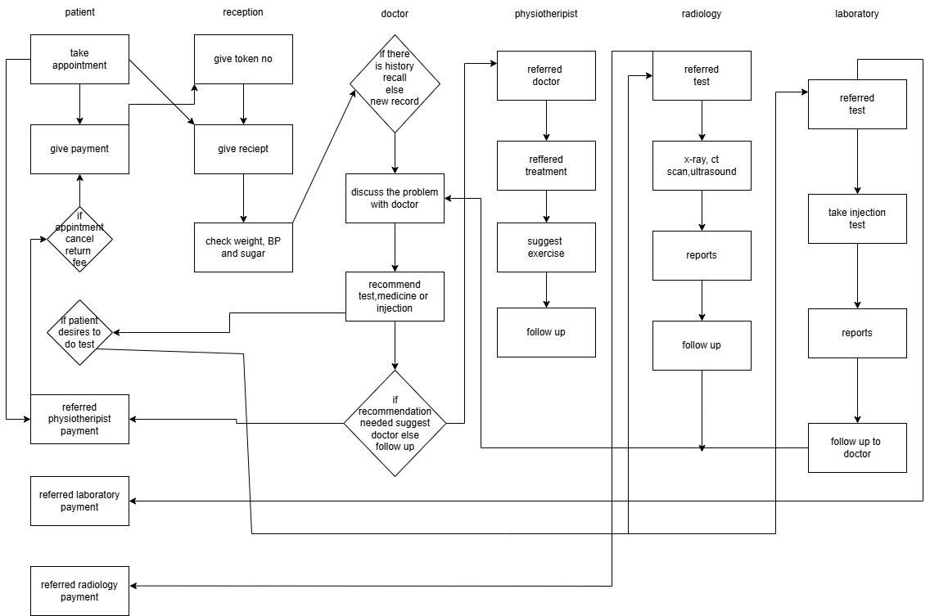

In figure 1.1, the swim lane process workflow of chemical manufacturing system is explained below:

Patient Interaction:
- Take Appointment: The patient books an appointment.
- Give Payment: The patient makes the necessary payment for the appointment.
- Cancellation: If the patient cancels the appointment, a refund or return fee process is initiated.
- Tests Decision: If the patient decides to proceed with a test, the process continues to the relevant department.
Reception Activities:
- Issue Token: Reception assigns a token number to the patient.
- Provide Receipt: A receipt is generated and given to the patient.
- Initial Check: The patient's weight, blood pressure, and sugar levels are measured before meeting the doctor.
Doctor Consultation:
- Check Medical History: If the patient has visited before, the doctor reviews the history; otherwise, a new record is created.
- Discuss Problems: The doctor discusses the patient’s condition and symptoms.
- Recommendations: Based on the consultation:
  - Recommend tests, medications, or injections.
  - If required, refer the patient to a specialist (physiotherapist, laboratory, or radiology).
Physiotherapy Process:
- Referred to Physiotherapist: The patient is referred to the physiotherapist by the doctor.
- Treatment Plan: The physiotherapist suggests exercises and a treatment plan.
- Follow-Up: Regular follow-ups are conducted to monitor progress.
Radiology Process:
- Referred for Tests: The patient is referred for imaging tests like X-rays, CT scans, or ultrasounds.
- Generate Reports: Test results are generated and provided to the patient.
- Follow-Up: The patient returns to the doctor for further diagnosis or treatment based on the reports.
Laboratory Process:
- Referred for Lab Tests: The patient is referred to the laboratory for diagnostic tests or injections.
- Generate Reports: Lab reports are prepared and shared with the patient.
- Follow-Up: The patient consults with the doctor again for interpretation of the lab results and further treatment.
•
Context Diagram of Hospital Management System:
"This context diagram provides an overview of the high-level process of the Hospital Management System. It outlines the key components of the system, including Patients, Doctors, Physiotherapists, Reception, Laboratory, and Radiology, and illustrates their interactions. The diagram highlights the system's relationships with external entities, such as error management, delays , offering a comprehensive glance at the hospital's operational workflow."
Figure 2.1-Context Diagram for Hospital Management System:

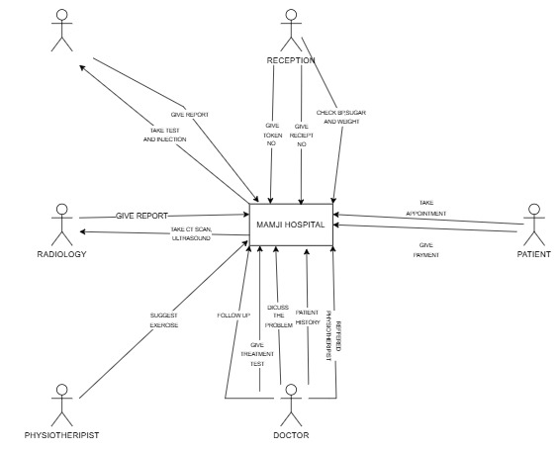

In figure 2.1, the Context diagram of Hospital Management system is explained below:
- Patient:
  - Input to Hospital: Takes appointments, provides payment for services, and shares personal and medical details.
  - Output from Hospital: Receives treatment, reports, and tokens for services.
- Reception:
  - Collects basic patient details, issues tokens, and provides receipts.
  - Checks initial health parameters like sugar levels and weight.
  - Directs patients to other hospital departments for further assistance.
- Doctor:
  - Discusses the patient's problem, reviews their medical history, and performs a diagnosis.
  - Suggests treatment plans, tests, or follow-ups as needed.
- Physiotherapist:
  - Recommends exercises or therapy based on the patient’s recovery needs.
- Radiology:
  - Conducts medical scans like CT scans and ultrasounds.
  - Provides diagnostic reports for further medical evaluation.

Data Flow
- Patients interact with the reception for registration and proceed to relevant departments based on referrals.
- Each department (Doctor, Physiotherapist, Radiology) sends and receives information through the hospital system for coordinated care delivery.

USE-CASE Diagram for Hospital Management System:
The Use-Case diagrams are the system views describing the behavior as described by the users. below are the detailed roles of each user and the general outlook of the entire CMS.

Figure 3.1-Use-case Diagram of Hospital Management System (BMS):

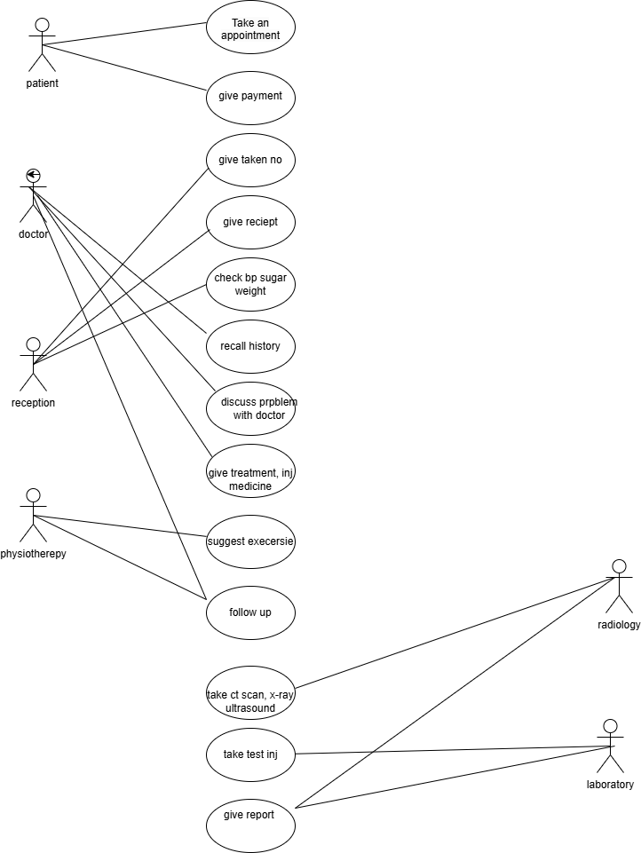

Figure 3.2-Use-case Diagram for the Patient:

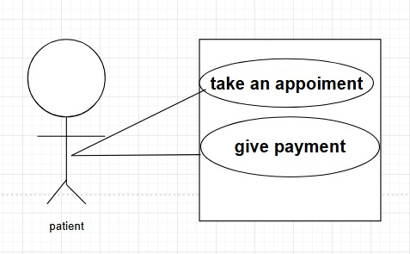
Description:

- Use-case begins when schedule an appointment for patient
- Use-case begins patient give payment to confirm the appointment
.

Figure 3.3-Use-case Diagram for the Reception :
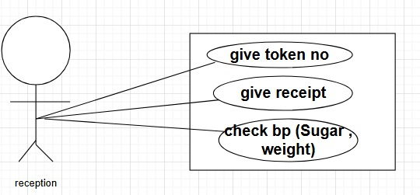

Description:

- Use-case begins after receiving the payment the receptionist will give token no.
- Use-case begins after confirming the appointment the receptionist will check BP, sugar, weight of patient.

Figure 3.4-Use-case Diagram for the Doctor:
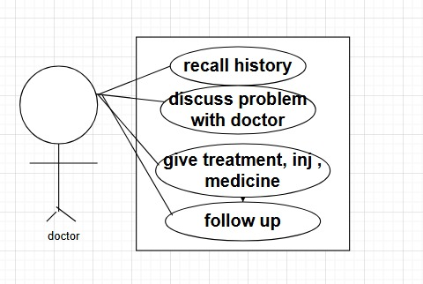

Description:
- Use-case begins recall history for the patient treatment.
- To facilitate a discussion between the patient and the doctor regarding patient health.
- Use-case begins after treatment plan doctor suggest injection and test.
- Use-case begins after treatment plan doctor suggest follow up date.

Figure 3.5-Use-case Diagram for Physiotherapist:
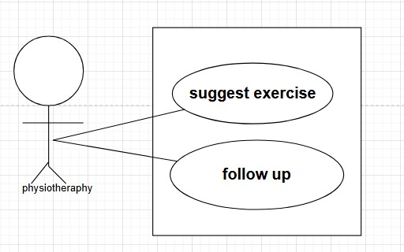

Description:
- Use-case begins after discussion with patient the physiotherapist suggests relevant exercise.
- Use-case begins after treatment plan doctor suggest follow up date.

Figure 3.6-Use-case Diagram for the Laboratory:
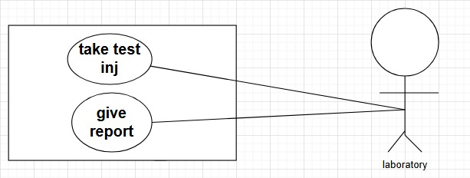

Description:
- Use-case begins after the discussion with patient the doctor will provide relevant treatment.
- The laboratory department will give reports to patient.

Figure 3.7-Use-case Diagram for the Radiology :

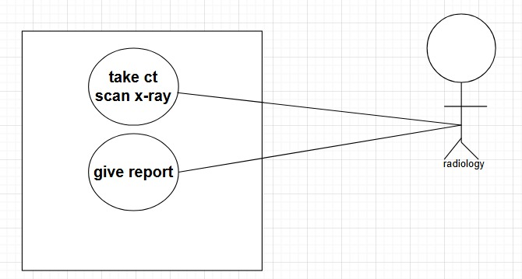

Description:
- Use-case begins after treatment plan doctor suggest CT Scan , X-Ray and Ultrasound.
- The radiology department will give reports to patient.

For j = 1 to no. of use cases

- Take appointment
Analysis use case documentation:
- Use case name: take appointment
- Source: rheumatology
- Primary business actor: patient
- Primary system actor: reception
- Other participation actor: doctor
- Other interested stakeholder: laboratory, radiology
- Description: to schedule an appointment for patient
- Trigger: this use case is initiated when the patient decided to book an appointment
- Typical course of event :
- Actor Action:
Step 1: Patient request reception to schedule an appointment
Step 3: The patient informs the reception the type of doctor needed
Step 5: the patient confirm the date and time
Step 7: The patient share their information
Step 9: The patient give payment for confirm the appointment
- System Response:
Step 2: the reception ask the patient the type of doctor
Step 4: The reception inform doctor day and time available
Step 6: The reception ask the information about patient
Step 8: The reception confirm the appointment and ask for payment
Step 10: After receiving the payment the reception give token no and receipt
- Alternative course:
step 10: if the patient cancel appointment return payment.
- Conclusion: The use case conclude when the patient receive token no and receipt .
- Post condition: The patient is notified of the appointment through sms on phone. The recipient has recorded all the necessary details in the system.
- Business rule: the patient must provide valid information.
- Implements constraints and specification: The receptionist manage booking. Check doctor availability and notify both doctor and patient.
- Open case: none.

- Give Payment
Analysis use case documentation:

- Use case name: give payment
- Source: rheumatology
- Primary business actor: patient
- Primary system actor: reception
- Other participation actor: doctor
- Other interested stakeholder: laboratory , radiology.
- Description: patient give payment to confirm the appointment
- Trigger: this use case is initiated when patient confirm an appointment.
- Typical course of event :
- Actor Action:
Step 1: patient give payment to confirm an appointment
- System Response:
Step 2: after receiving the payment reception give token no and receipt.
- Alternative course:
Step 1: if patient cancel the appointment return the payment.
- Conclusion: the use case concludes when the patient receives the token no and receipt.
- Precondition: the patient wants to book appointment .
- Post condition: the patient is notifies of the appointment through SMS/phone.
- Business rule: the patient pays full payment.
- Implements constraints and specification: the receptionist confirm an appointment and notify doctor and patient.
- Open case: none.

- Give token no and receipt
Analysis use case documentation:

- Use case name: give token no and receipt
- Source: rheumatology
- Primary business actor: reception
- Primary system actor: patient
- Other participation actor: doctor
- Other interested stakeholder: laboratory, radiology
- Description: after receiving the payment the receptionist will give token no.
- Precondition: the patient will give payment to confirm an appointment
- Trigger: this use case is initiated when the patient give payment to confirm appointment
- Typical course of event :
- Actor Action:
Step 1: after receiving the payment the receptionist will give token no and receipt.
- System Response:
Step 2: the patient will receive the token no and receipt.
- Alternative course:
if patient doesn’t give payment the token no and receipt will not be generated
- Conclusion: this use case concludes when patient receives the token no and receipt.
- Post condition: the patient will notify about the appointment.
- Business rule: the patient must receive valid token no and receipt
- Implements constraints and specification: after giving the token no and receipt the receptionist will notify both doctor and payment.

- check BP, sugar, weight.
Analysis use case documentation:

- Use case name: check BP, sugar, weight.
- Source: rheumatology
- Primary business actor: reception
- Primary system actor: patient
- Other participation actor: doctor
- Other interested stakeholder: laboratory, radiology.
- Description: after confirming the appointment the receptionist will check BP, sugar, weight of patient.
- Precondition: patient has an appointment
- Trigger: this use case is initiated when patient appears for appointment
- Typical course of event :
- Actor Action:
Step 1: the recpeitonist calls the patient
Step 3: the reception check patient BP, sugar, weight and write it to the patient’s file
And give to doctor.
- System Response:
Step 2: the patient comes to reception
Step 4: the patient go to the doctor.
- Alternative course:
Step 1: the patient doesn’t show on the appointment time, means he/she is not available.
- Conclusion: this use case concludes wen patient go to doctor for treatment.
- Post condition: the report will go to doctor.
- Implements constraints and specification: the receptionist write BP, sugar, weight and give to doctor.
- Business rule: the receptionist check BP, sugar, weight correctly.
- Open case: none.

- Recall History
Analysis use case documentation:
- Use case name: recall history
- Source: rheumatology
- Primary business actor: doctor
- Primary system actor: patient
- Other participation actor: physiotherapist, laboratory, radiology.
- Other interested stakeholder: reception
- Description: recall history for the patient treatment.
- Precondition: the patient has the appointment.
- Trigger: this use case is initiated when the patient appears on appointment.
- Typical course of event :
- Actor Action:
Step 1: the doctor reviews the patient history and doctor ask related questions.
- System Response:
Step 2: the patient answer the doctor’s queries.
- Alternative course:
Step 1: the patient has no history then ask patient problem.
- Conclusion: the use case concludes when doctor recall the history of patient.
- Post condition: the patient receive necessary treatment.
- Business rule: the patient must have valid history.
- Implements constraints and specification: the doctor discuss the treatment to the patient.
- Open case: none.

- Discussion with Doctor
Analysis use case documentation:

- Use case name: discussion with doctor
- Source: rheumatology.
- Primary business actor: doctor
- Primary system actor: patient
- Other participation actor: physiotherapist, laboratory, radiology
- Other interested stakeholder: reception
- Description: to facilitate a discussion between the patient and the doctor regarding patient health.
- Precondition: the patient has an appointment with doctor.
- Trigger: this use case is initiated when the patient appears on the appointment date.
- Typical course of event:
- Actor Action:
Step 1: The doctor reviews patient history and ask about patient current problem.
Step 3: doctor prescribe the treatment.
- System Response:
Step 2: patient share their problem with doctor.
Step 4: patient take the prescription and ask if there are any related questions.
- Alternative course:
Step 1: if the patient has no history then ask the patient problems.
Step 3: if patient needs physiotherapist then referred a physiotherapist and if any test needed suggest the test form laboratory and if any x-ray, CT scan needed suggest to radiology department.
- Conclusion: this use case concludes when the patient receives the prescription from doctor.
- Post condition: the patient receive necessary follow up date, referrals or prescriptions.
- Business rule: the patient must provide valid problems.
- Implements constraints and specification: patient and doctor discuss the problem and doctor provides the treatment plan.
- Open case: none.
- Give treatment, injection, medicine
Analysis use case documentation:

- Use case name: give treatment, injection, medicine.
- Source: rheumatology.
- Primary business actor: doctor.
- Primary system actor: patient.
- Other participation actor: laboratory, radiology, physiotherapy.
- Other interested stakeholder: reception.
- Description: after the discussion with patient the doctor will provide relevant treatment.
- Precondition: the patent has discussion with doctor.
- Trigger: this use case is initiated when doctor give the treatment of patient’s problems.
- Typical course of event:
- Actor Action:
- Step 1: after discussing the problems with the patient doctor will suggest the treatment.
- System Response:
- Step 2: patient will ask if he has any question.
- Alternative course: none.
- Conclusion: this use case concludes when patient receive treatment plan.
- Post condition: the patient will follow doctor’s treatment.
- Business rule: doctor must provide valid treatment.
- Implements constraints and specification: patient and doctor discuss the problems and doctor gives the treatment.
- Open case: none.

- Suggest Exercise
Analysis use case documentation:

- Use case name: suggest exercise
- Source: rheumatology
- Primary business actor: physiotherapist
- Primary system actor: patient
- Other participation actor: doctor, radiology, laboratory
- Other interested stakeholder: reception
- Description: after discussion with patient the physiotherapist suggests relevant exercise.
- Precondition: doctor referred patient to physiotherapist.
- Trigger: this use case is initiated when the patient discuss problem with physiotherapist
- Typical course of event:
- Actor Action:
- Step 1: after checking with the doctor physiotherapist suggest exercise.
- System Response:
- Step 2: patient will ask if he has any question.
- Alternative course: after checking with the doctor, if he doesn’t need exercise then follow up with the doctor.
- Conclusion: this use case concludes when patient receive exercise plan.
- Post condition: patient will follow up with exercise.
- Business rule: physiotherapist must provide valid exercise.
- Implements constraints and specification: patient and physiotherapist discuss constraints and the problems and physiotherapist specification give the exercise.

- Follow up
Analysis use case documentation:

- Use case name: follow up.
- Source: rheumatology
- Primary business actor: doctor, physiotherapist
- Primary system actor: patient
- Other participation actor: reception
- Other interested stakeholder: radiology, laboratory
- Description: after treatment plan doctor suggest follow up date.
- Precondition: doctor have given a treatment plan.
- Trigger: this use case is initiated when the patient has received treatment plan.
- Typical course of event:
- Actor Action:
- Step 1: after discussion the treatment plan doctor suggest follow up date.
- System Response:
- Step 2: patient will book an appointment for next follow up.
- Alternative course:
- Step 2: if patient doesn’t want to follow up with doctor.
- Conclusion: this use case concludes when doctor suggest next follow up date.
- Post condition: the patient will take appointment next follow up.
- Business rule: doctor must suggest valid follow up date.
- Implements constraints and specification: patient have next follow up appointment.

- Take CT Scan, X-Ray, Ultrasound.
Analysis use case documentation:

- Use case name: take CT Scan, X-Ray, Ultrasound.
- Source: rheumatology
- Primary business actor: radiology.
- Primary system actor: patient.
- Other participation actor: reception, doctor.
- Other interested stakeholder: physiotherapist.
- Description: after treatment plan doctor suggest CT Scan, X-Ray and Ultrasound.
- Precondition: doctor will suggest necessary treatment, CT Scan, X-Ray, Ultrasound.
- Trigger: this use case is initiated when patient needed CT Scan, X-ray, Ultrasound.
- Typical course of event:
- Actor Action:
- Step 1: the radiology department will give patient necessary test prescribed by doctor.
- System Response:
- Step 2: the patient will collect reports.
- Alternative course:
- Step 1: if patient doesn’t want to take test.
- Conclusion: this use case concludes when patient will receive the test reports.
- Post condition: the patient will give reports to the doctor.
- Business rule: doctor must provide valid test.
- Implements constraints and specification: the radiology department will give reports and specification.

- Take injection and test.
Analysis use case documentation:

- Use case name: take injection and test.
- Source: rheumatology.
- Primary business actor: laboratory.
- Primary system actor: patient.
- Other participation actor: doctor, reception
- Other interested stakeholder: radiology.
- Description: after treatment plan doctor suggest injection and test.
- Precondition: doctor will suggest necessary test and injection.
- Trigger: this use case is initiated when patient need test and injection.
- Typical course of event :
- Actor Action:
Step 1: the laboratory department will give patient necessary test and injection prescribed by doctor.
- System Response:
Step 2: the patient will collect the report.
- Alternative course:
Step 1: if patient doesn’t want to take test.
- Conclusion: this use case concluded when patient will receive the test report.
- Post condition: the patient will give reports to the doctor.
- Business rule: doctor must provide valid test.
- Implements constraints and specification: the laboratory department will give reports and specification.

- Give Report
Analysis use case documentation:

- Use case name: give reports.
- Source: rheumatology.
- Primary business actor: radiology, laboratory.
- Primary system actor: patient.
- Other participation actor: doctor, physiotherapist.
- Other interested stakeholder: reception.
- Description: the radiology and laboratory department will give reports to patient.
- Precondition: the patient will give the test.
- Trigger: this use case is initiated when patient will take the test prescribed by doctor.
- Typical course of event:
- Actor Action:
Step 1: the radiology and laboratory department will give report to patient.
- System Response:
Step 2: the patient will collect the report and give it to the doctor.
- Alternative course: none.
- Conclusion: this use case conclude when patient receive reports.
- Post condition: when patient follow up wit doctor.
- Business rule: laboratory and radiology must provide valid reports.
- Implements constraints and specification: the doctor checks reports and give treatment.
- open case: none.

Figure 4.1-Complete Object Diagram of Hospital Management System:

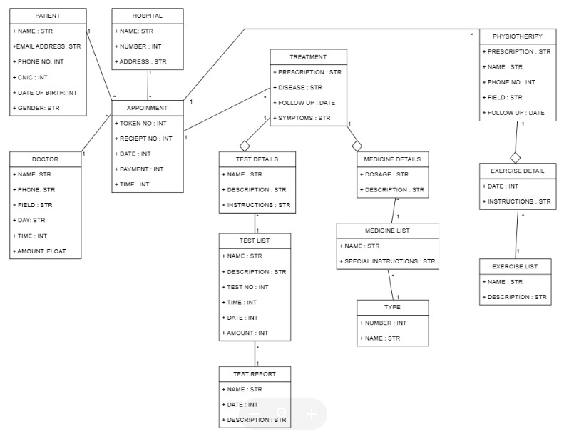

Figure 5.1-Sequence Diagram of Hospital Management System:

In figure 5.1, the sequence diagram of Hospital Management system is explained below:

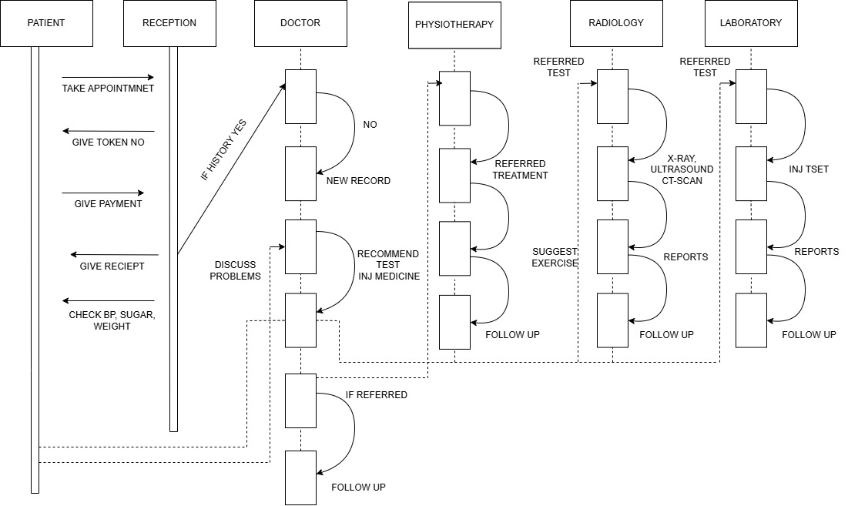

Figure 6.1- Input Design Prototype of Login :

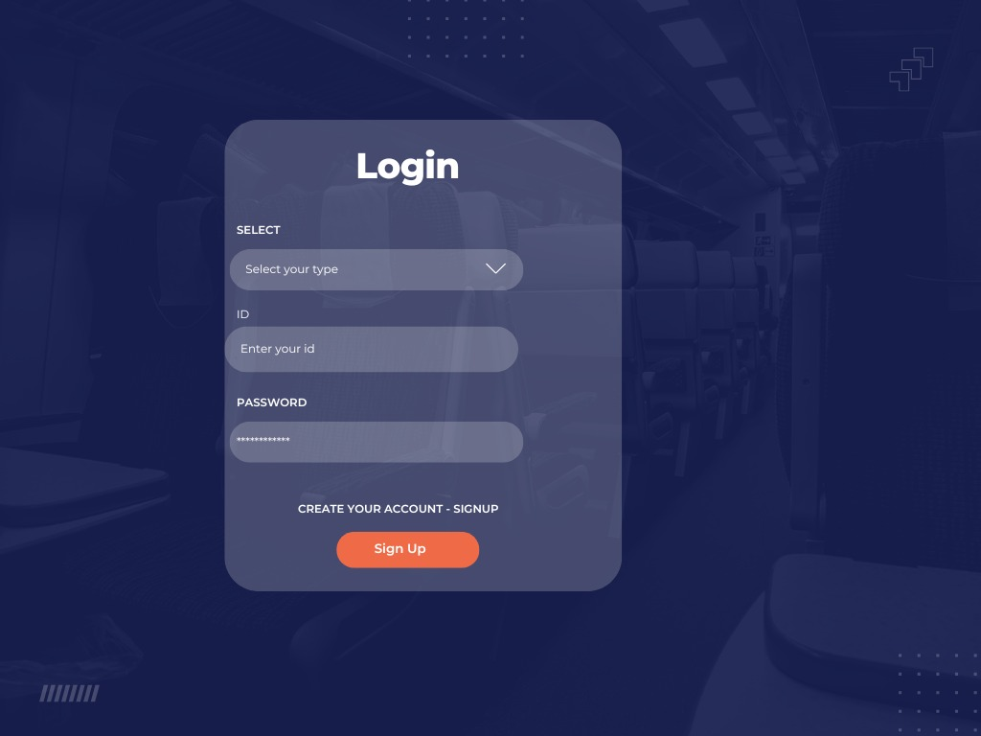

Figure 6.2- Input Design Prototype of sign up :

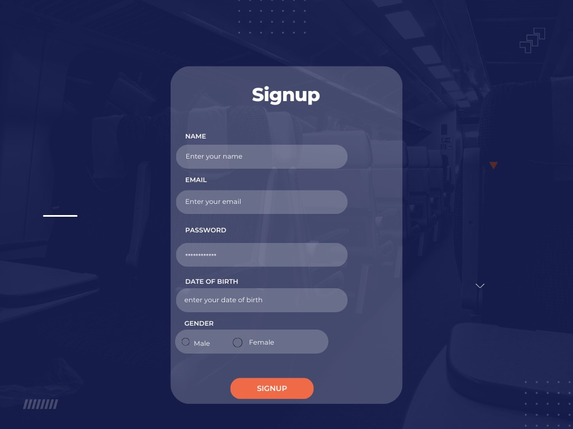

Figure 6.3-Sequence Diagram of Book an Appointment:

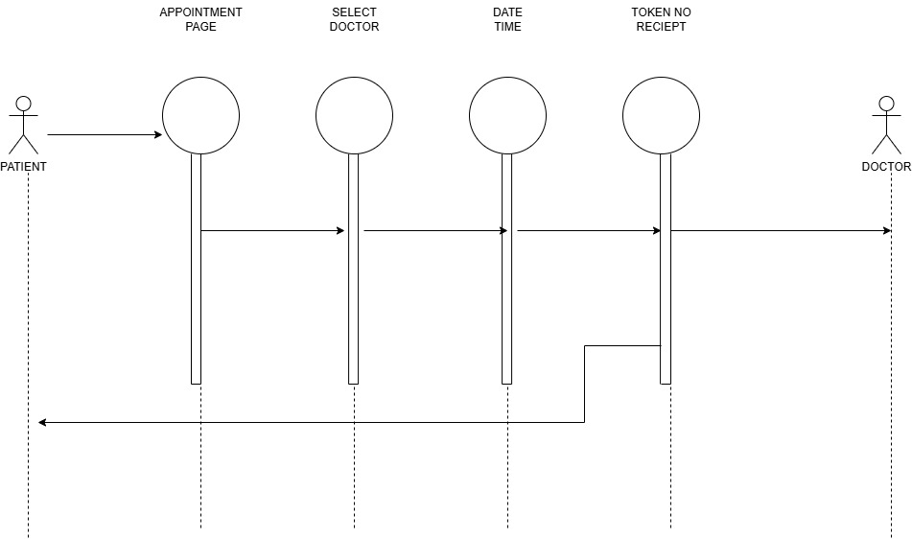
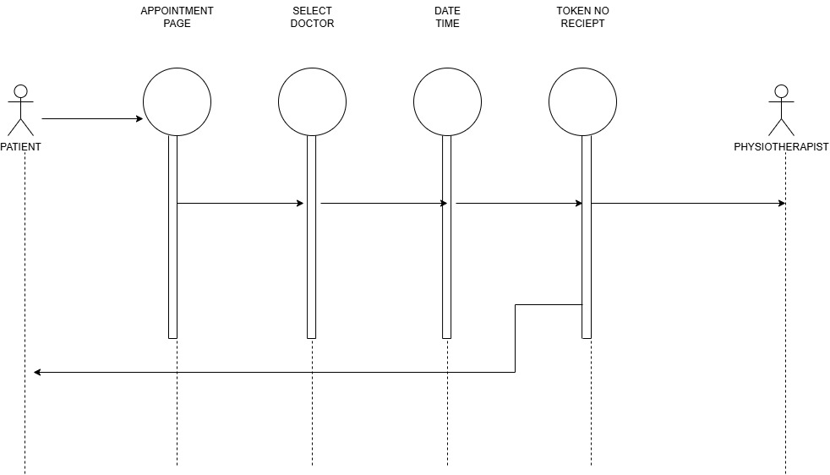

Figure 6.4-Input Design Prototype of Book an Appointment:

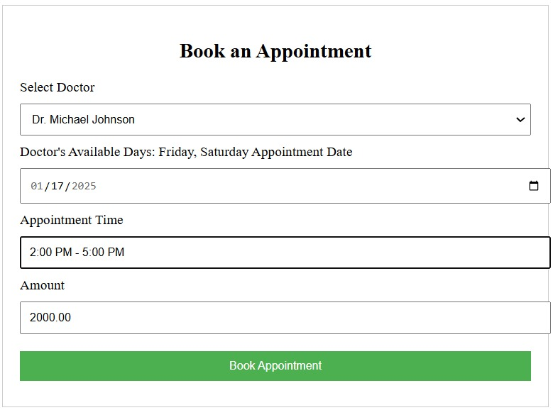this is a form interface for booking an appointment.
- Select Doctor: Choose a doctor from a dropdown list.
- Doctor's Available Days: Displays the days the selected doctor is available.
- Appointment Date: Pick the desired date for the appointment using a date picker.
- Appointment Time: Indicates the available time slot for appointments.
- Amount: Input the payment or consultation fee (if applicable).
- Book Appointment: A button to confirm and submit the booking.

Figure 6.5-Input Design Prototype of Appointment Detail:

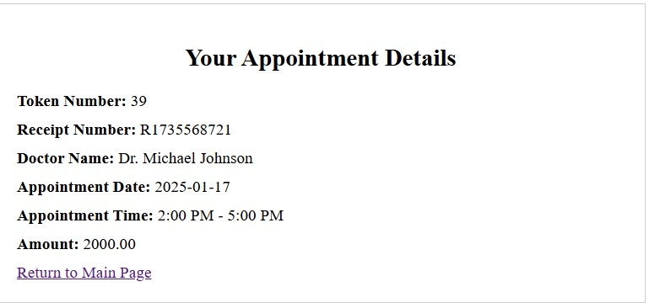
This is a confirmation page showing the details of a booked appointment.
- Token Number: Unique identifier for the appointment in the system.
- Receipt Number: Reference number for payment or booking confirmation.
- Doctor Name: The name of the doctor the appointment is scheduled with.
- Appointment Date: The selected date for the appointment .
- Appointment Time: The time slot for the appointment .
- Amount: The fee for the appointment .
- The "Return to Main Page" link allows users to navigate back to the main interface.

Figure 6.6-Output Design Prototype of Book an Appointment:

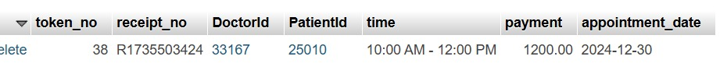

Figure 7.1- Sequence Diagram of lab test :
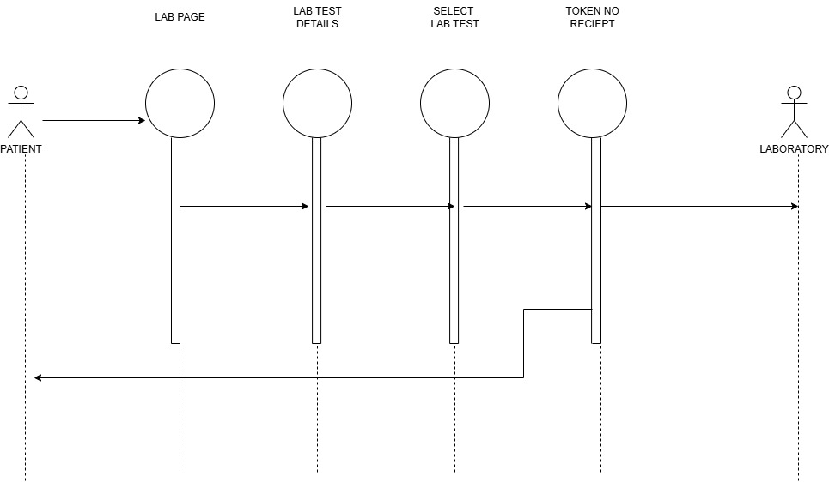

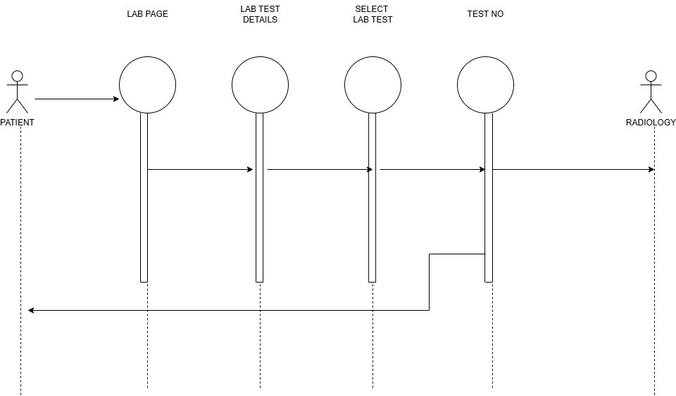

Figure 7.2- Input Design Prototype of lab test :

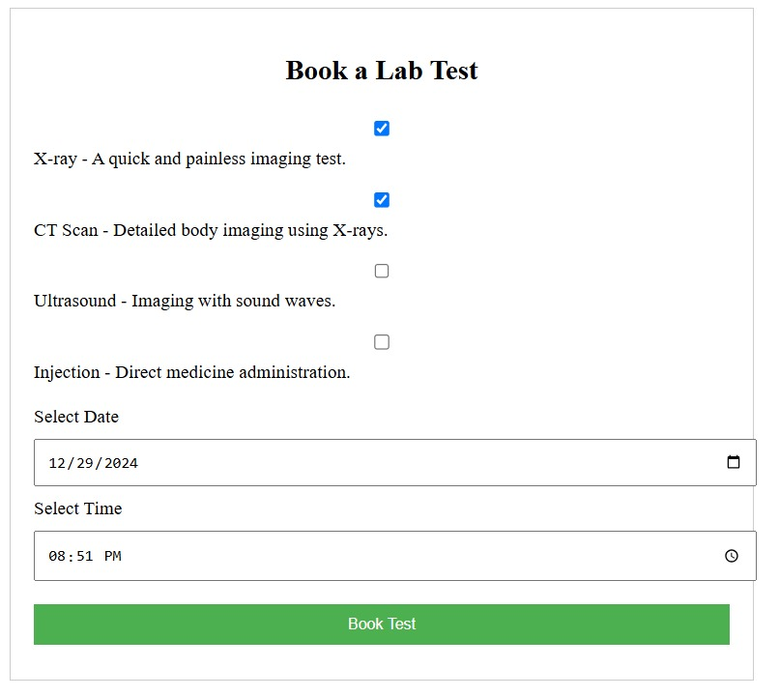
This is a form to book a lab test.
- Lab Test Options:
  - X-ray - A quick and painless imaging test. (Selected)
  - CT-Scan - Detailed body imaging using X-rays. (Selected)
  - Ultrasound - Imaging with sound waves.
  - Injection - Direct medicine administration.
- Date: 12/29/2024
- Time: 08:51 PM
- Action Button: Book Test

Figure 7.3-Input Design Prototype of Lab test detail:

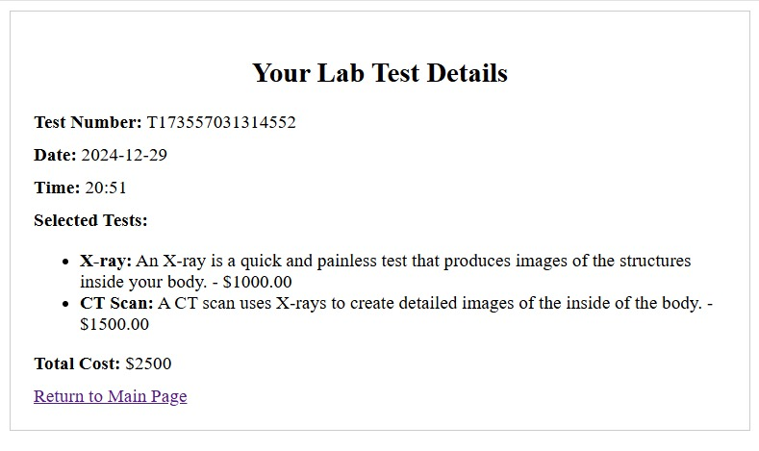
Test Number: This is a unique identifier for this specific set of tests.
Date: The date the tests were performed.
Time: 20:51
- The time the tests were performed.
Selected Tests:
- X-ray:
- CT -Scan:
Total Cost: The combined cost of both the X-ray and CT scan.
Return to Main Page:
- A link to navigate back to the main page of the lab

Figure 7.4-Input Design Prototype of Lab Test Report:
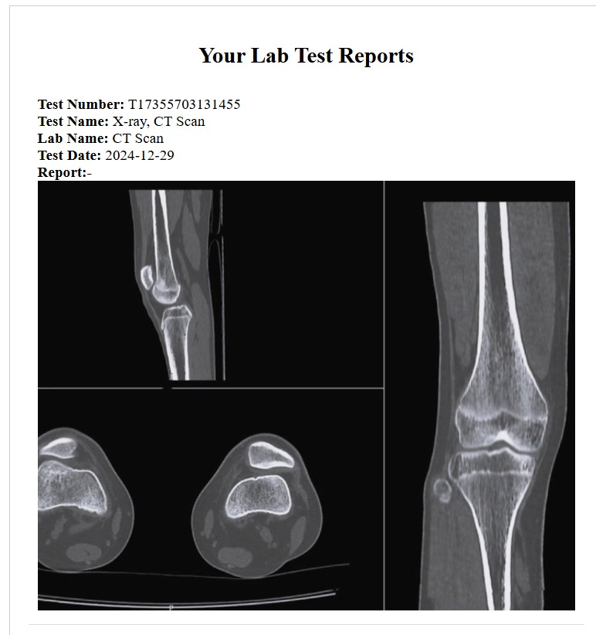

This how report generated after test these report come after 1 day.

Figure 7.5-Output Design Prototype of Lab Test:

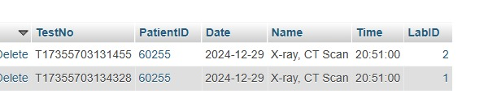

Figure 7.6-Input Design Prototype of view treatment:
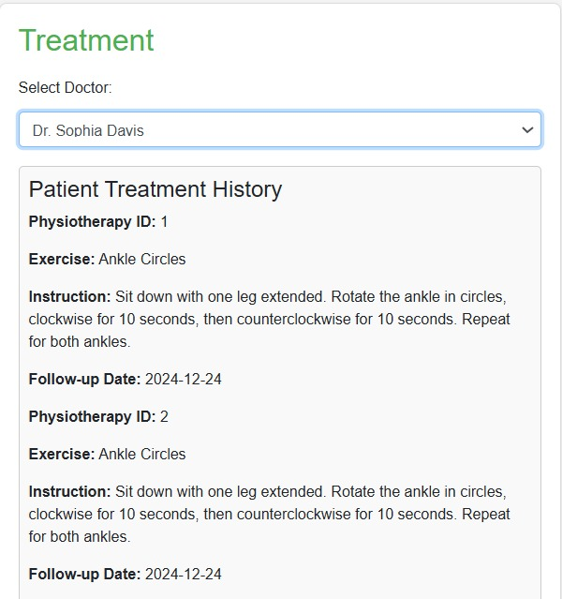

Here patient can view his treatment given by the Doctor:

- Select Doctor: This dropdown allows you to choose the doctor responsible for the treatment. In this case, Dr. Sophia Davis is selected.
Patient Treatment History
This section lists the physiotherapy exercises prescribed to the patient.
- Physiotherapy ID: A unique identifier for each exercise or set of exercises.
- Exercise: The name of the exercise. In this case, both IDs list "Ankle Circles."
- Instruction: A detailed description of how to perform the exercise.
- Follow-up Date: The date by which the patient should complete the exercise and potentially return for further assessment or adjustments.

Figure 8.1-Input Design Prototype of view Appointment :

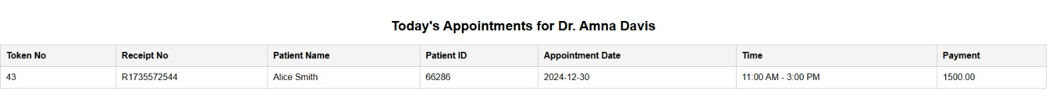

Figure 8.2-Input Design Prototype of Treatment :

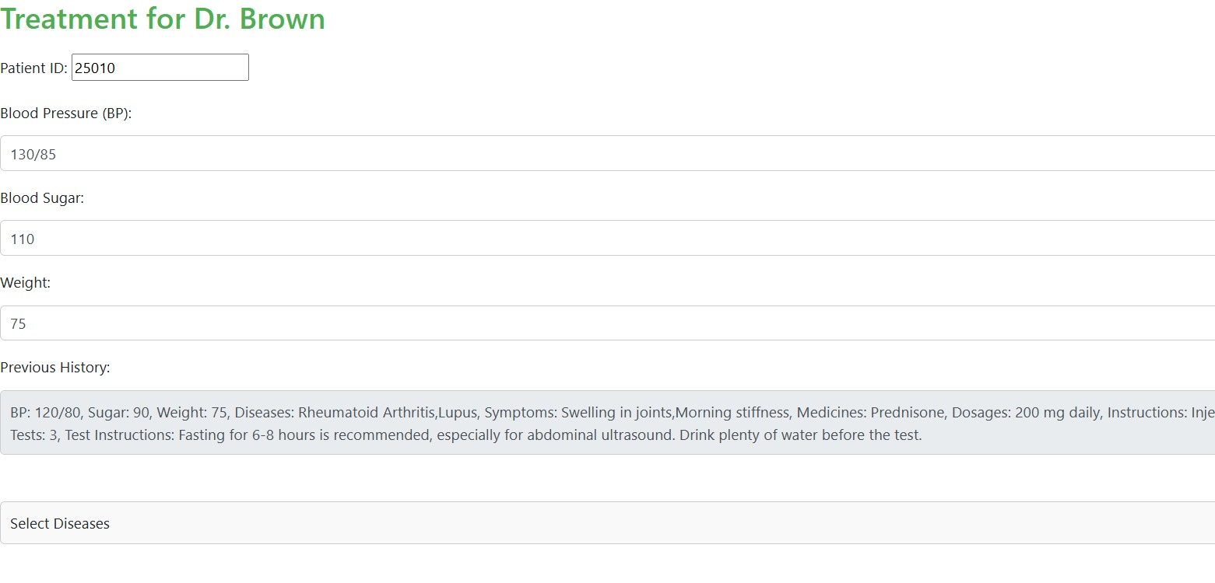

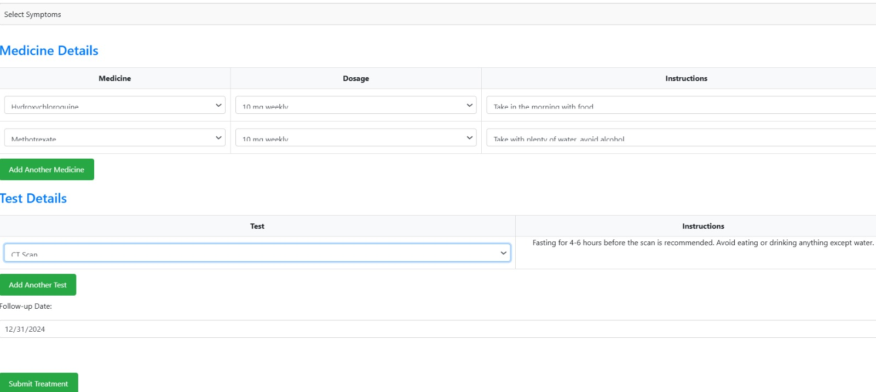

• Assessment : The doctor has recorded the patient's current vital signs (blood pressure, blood sugar, weight) and reviewed their medical history, including previous medications and test results.
• Diagnosis : The patient has been diagnosed with Rheumatoid Arthritis and Lupus.
• Treatment Plan : The doctor is prescribing two medications: Hydroxychloroquine and Methotrexate, with specific dosages and instructions. They are also scheduling a CT scan.
• Follow-up: The doctor has set a follow-up appointment for December 31, 2024.

Figure 8.3-Output Design Prototype of Treatment:

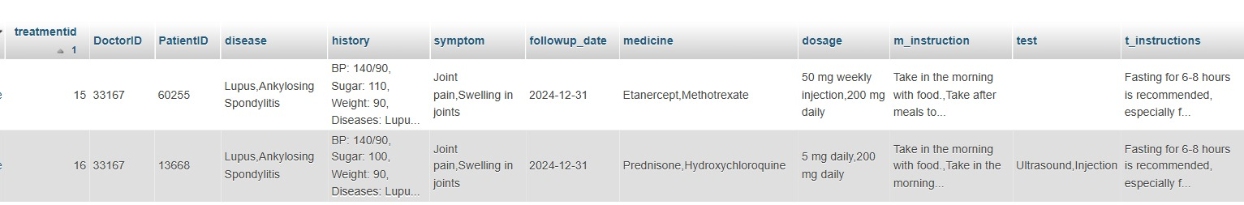

Figure 9.1-Input Design Prototype of view Appointment:

Figure 9.2-Output Design Prototype of Treatment:

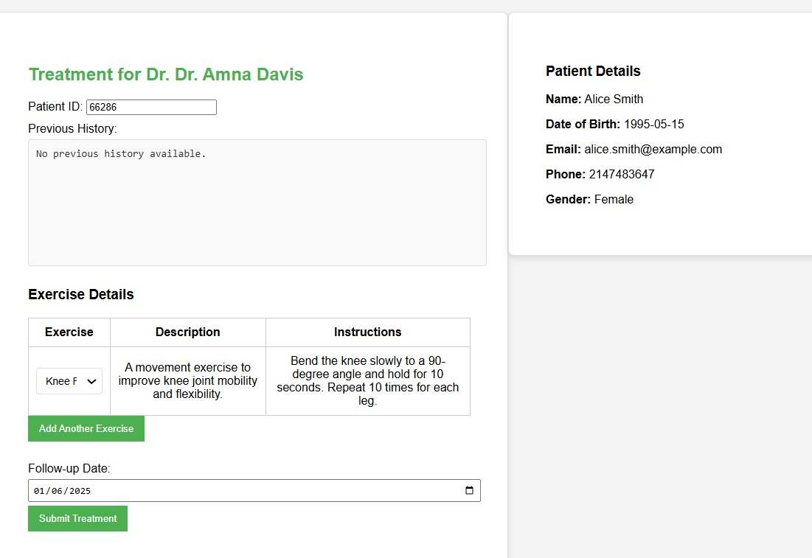

• Assessment & Planning: Dr. Amna Davis, the physiotherapist, has assessed Alice Smith's condition and determined that she needs exercises to improve knee joint mobility and flexibility.
• Treatment Prescription: Dr. Davis has prescribed a specific exercise called "Knee Flexion." The instructions for performing this exercise are clearly outlined in the form.
• Follow-up Scheduling: A follow-up appointment is scheduled for January 6, 2025. This allows Dr. Davis to monitor Alice Smith's progress, assess the effectiveness of the exercise, and make any necessary adjustments to the treatment plan.

Figure 10.1-Complete Class Diagram of Hospital Management System:

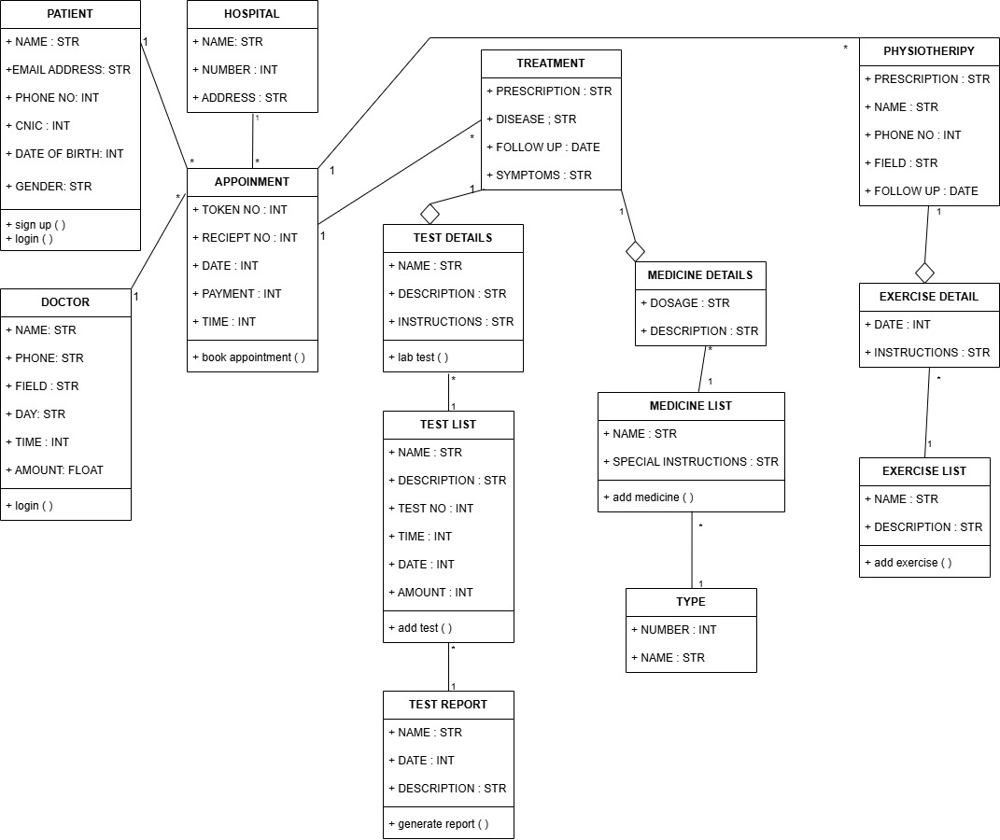

Figure 11.1-DataBase Diagram of Hospital Management System:

In figure 8.1, the database diagram of Hospital Management system is explained below:
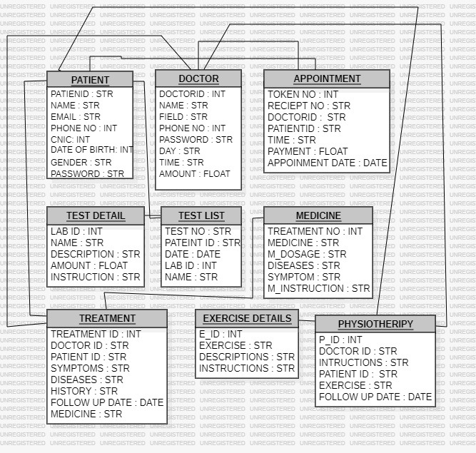

In actor usecase table, follow the table mentioned below
Usecase | Primary actor | system actor | other participating actor | other interested stakeholder
Take Appointment | Patient | Reception | Doctor, Physiotherapist | Laboratory, Radiology
Give payment | Patient | Reception | Doctor, Physiotherapist | Laboratory, Radiology
Give Token no, Receipt no | Reception | Patient | Doctor, Physiotherapist | Laboratory, Radiology
Check BP, Sugar, Weight | Reception | Patient | Doctor, Physiotherapist | Laboratory, Radiology
Recall History | Doctor | Patient | Laboratory, Radiology, Physiotherapist | Reception
Discussion with doctor | Doctor | Patient | Laboratory, Radiology, Physiotherapist | Reception
Give treatment,  injection, medicine | Doctor | Patient | Laboratory, Radiology, Physiotherapist | Reception
Suggest Exercise | Physiotherapist | Patient | Laboratory, Radiology, doctor | Reception
Follow up | Doctor, Physiotherapist | Patient | Reception | Laboratory, Radiology
Take injection, test | Laboratory | Patient | Doctor, Reception | Radiology
Take  CT-Scan,  X-Ray, Ultrasound | Laboratory, Radiology | Patient | Doctor, Reception | Physiotherapist

LIST OF REPORTS:
USECASE | Reports
Taking an Appointment | Detailed :  List of Patient  List of Services  List of Appointment  List of Doctor  Summary:  Patient based Appointment  Exception:  Missing History of Patient  External:  History  Turn around:  Payment, Receipt

USECASE | Reports
Treatment | Detailed :  List of Patient  List of Medicine  List of Test  List of Services  List of Doctor  Summary:  Patient based treatment  Exception:  Missing History of Patient  Missing Prescription of Patient  External:  Medical bill, Test bill, Prescription  Turn around:  Follow up

USECASE | Reports
Physiotherapy | Detailed :  List of Patient  List of Physiotherapist  List of Test  List of Exercise  Summary:  Patient based physiotherapy  Exception:  Missing History of Patient  Missing referred of Doctor  External:  Medical bill, Test bill  Turn around:  Follow up

MEDICAL BILL

MAAMJI HOSPITAL
FROM: TO:
MAAMJI HOSPITAL HABIBA AZFAR
WATER PUMP GULSHAN-E-IQBAL
KARACHI, 75950 KARACHI, 75990
03346901749 03346901749
DATE | PATIENT ID | PAYMENT METHOD | DUE DATE | TERMS
31-DEC-24 | 12345 | CASH | 2-JAN-25 | NET 30

SERIAL NO | DESCRIPTION | QUANTITY | UNIT PRICE | AMOUNT
01 | DRIP | 2 | 1000 | 2000
02 | INJECTION | 2 | 400 | 800
03 | MEDICINE | 5 | 200 | 1000

3800
1000
4800
SUBTOTAL

TAX
TOTAL

TEST BILL

MAAMJI HOSPITAL
FROM: TO:
MAAMJI HOSPITAL HABIBA AZFAR
WATER PUMP GULSHAN-E-IQBAL
KARACHI, 75950 KARACHI, 75990
03346901749 03346901749
DATE | PATIENT ID | PAYMENT METHOD | DUE DATE | TERMS
31-DEC-24 | 12345 | CASH | 2-JAN-25 | NET 30

SERIAL NO | DESCRIPTION | QUANTITY | UNIT PRICE | AMOUNT
01 | CT-SCAN | 2 | 1000 | 2000
02 | X-RAY | 2 | 4000 | 8000
03 | ULTRASOUND | 5 | 2000 | 6000

12000
1000
13000
SUBTOTAL

TAX
TOTAL

PRESCRIPTION

MAAMJI HOSPITAL
FROM: TO:
MAAMJI HOSPITAL HABIBA AZFAR
WATER PUMP GULSHAN-E-IQBAL
KARACHI, 75950 KARACHI, 75990
03346901749 03346901749

DATE | Complaint | Observations | Diagnosis | Investigations
31-DEC-24 | Full Body Pain, Weakness Feeling | High Body Temperature, Reddish eye | Dengue | Creatine  CBC Count

Medicine | Dosage | Duration | instructions
Tab Rantac 150mg | 1-1-1 | 3 days | After Meal
CAP SM FIBRO | 1-0-1 | 5 days | Before Meal
Remarks: Keep measuring body Temp. twice a day.
Next follow-up date: Friday May 03, 2019 5:00 PM

IMPLEMENTATION
In this chapter you have to add actual form and report layouts, component diagram, and deployment diagram.

Figure 12.1- Deployment Component Diagram of Hospital Management System:

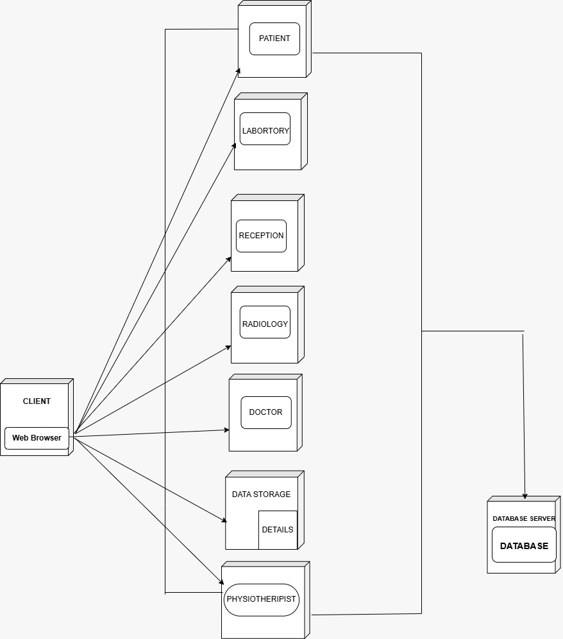

In figure 3.1, the Component diagram of Boiler Management system is explained below:

Component Diagram
- Client: Represents the user interface, accessed via a web browser.
- Data Storage: Stores the patient's information, including details, medical records, and appointments.
- Database Server: Hosts the database containing all the patient's data.
- Database: The actual database containing all information.
- Reception: Manages patient appointments, scheduling, and registration.
- Doctor: Handles patient consultations, diagnosis, and treatment plans.
- Laboratory: Provides medical tests and analysis.
- Radiology: Performs imaging tests, like X-rays and MRIs.
- Physiotherapist: Offers physical therapy and rehabilitation services.
- Patient: Represents the patient using the system.
- Details: Contains specific information about the patient, such as name, address, and contact details.

Deployment Diagram

In figure 3.1, the Deployment diagram of Boiler Management system is explained below:

- Application server is the main server which is connected with every server and device.
- The Database server is also connected with the application server, where all the data has been stored.
- Patient also connected with the application server where patient book an appointment ,book lab test ,view report and treatment.
- Doctor also connected with the application server where doctor can give treatment and save .check its daily appointment
- Physiotherapist is connected with application server where physiotherapist can give treatment and also save it to database and check daily appointment.

COMPANY EVIDENCIES:

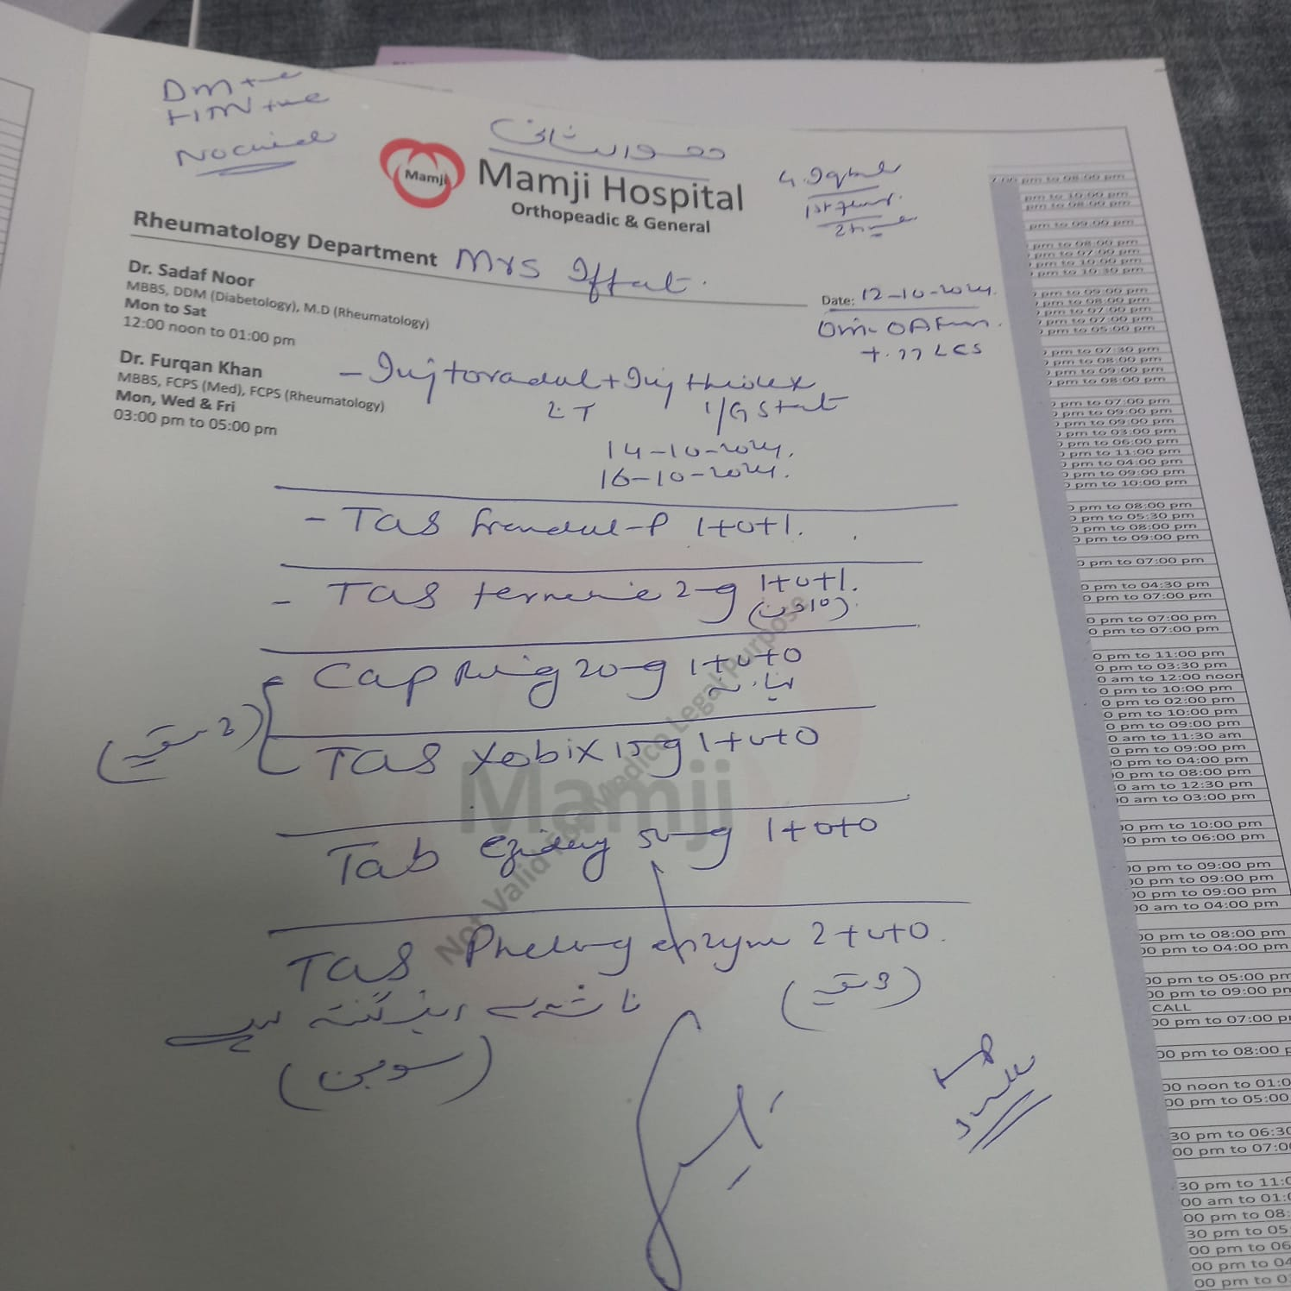

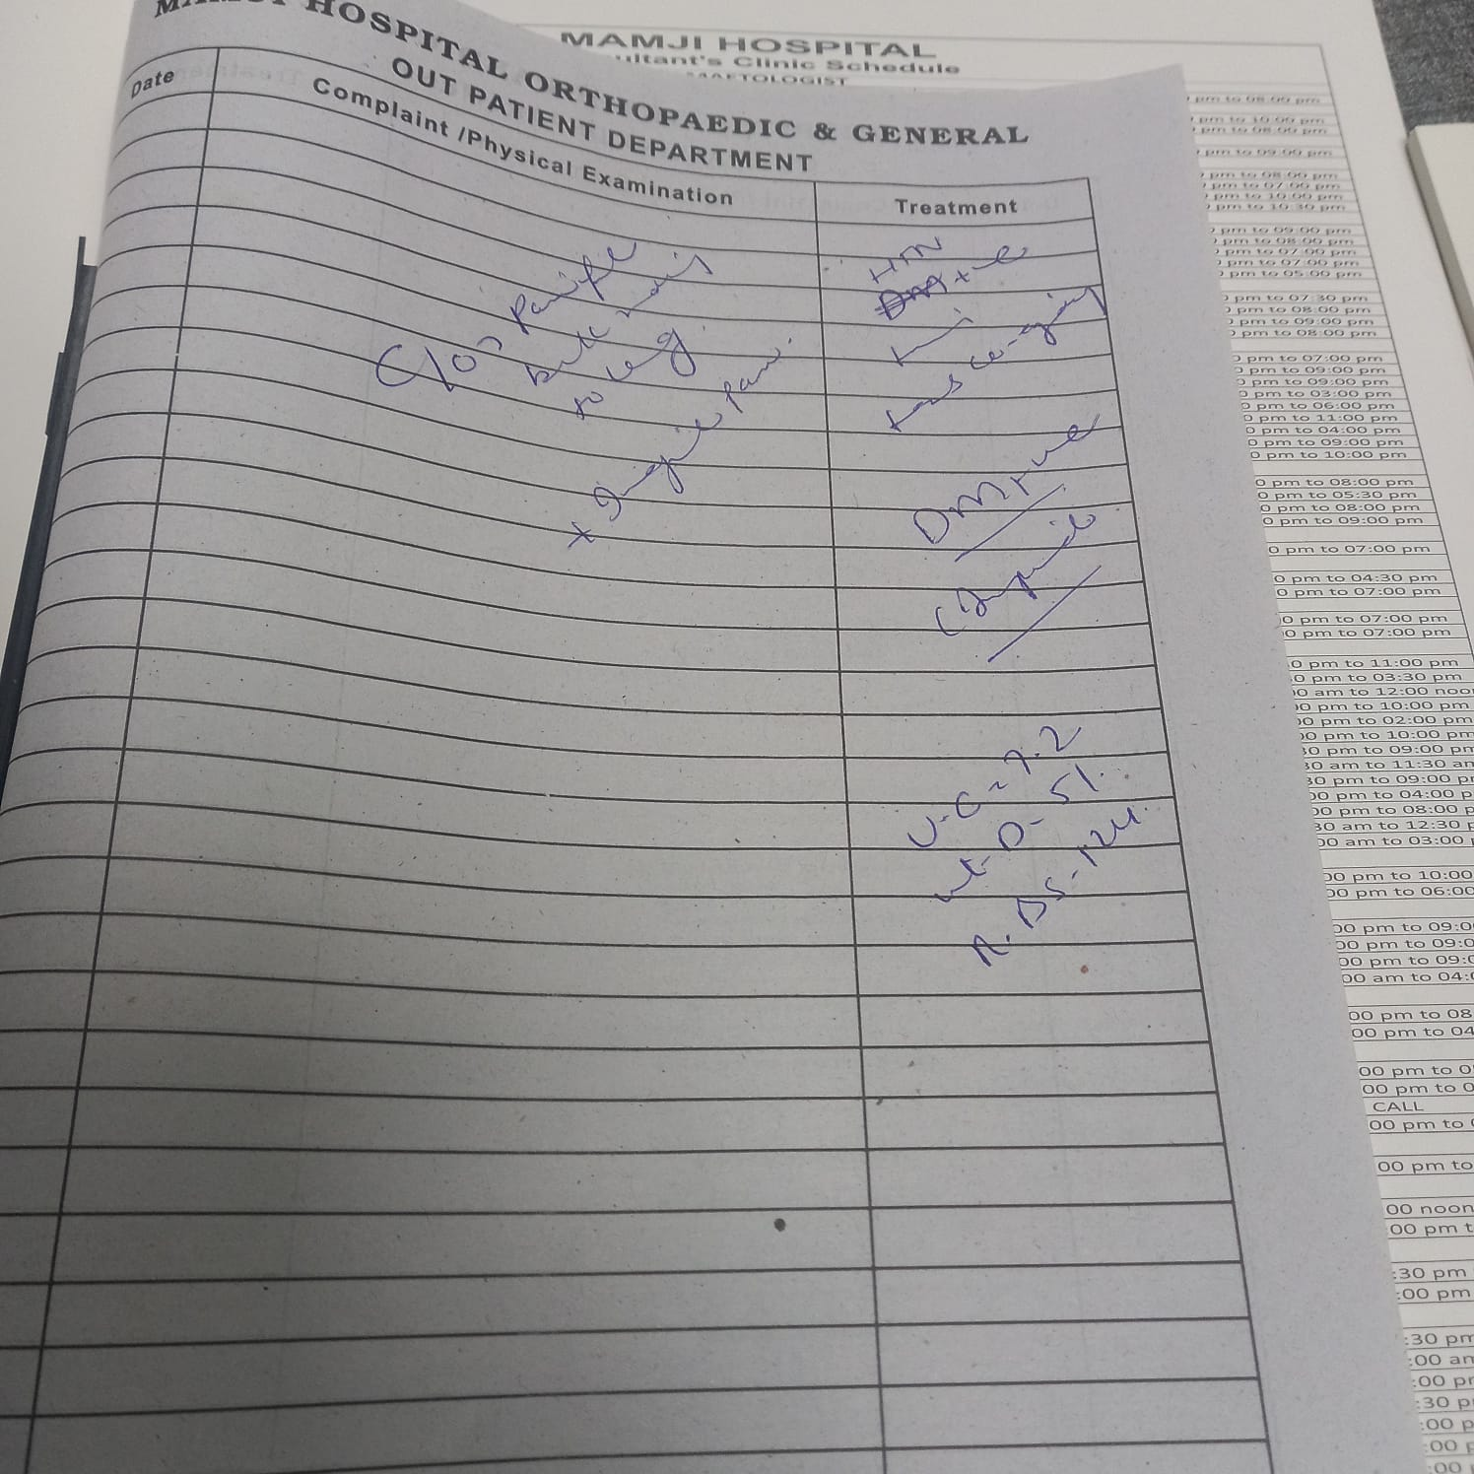

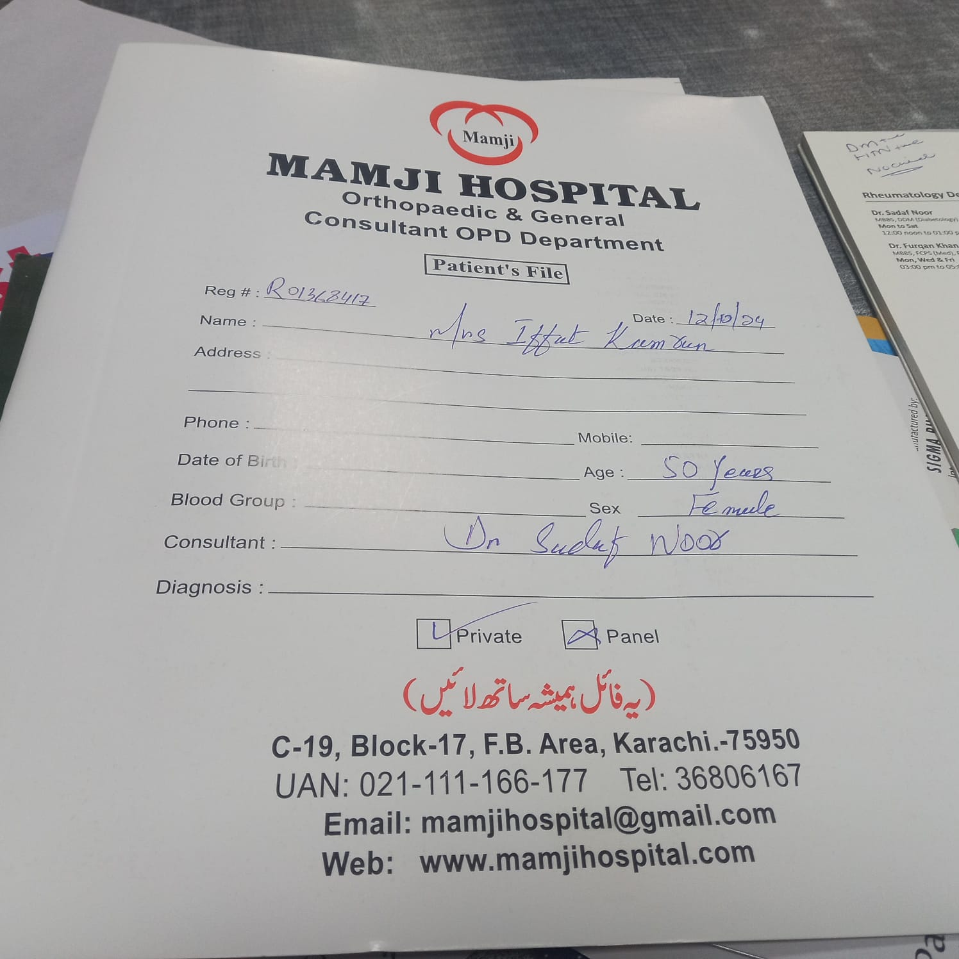

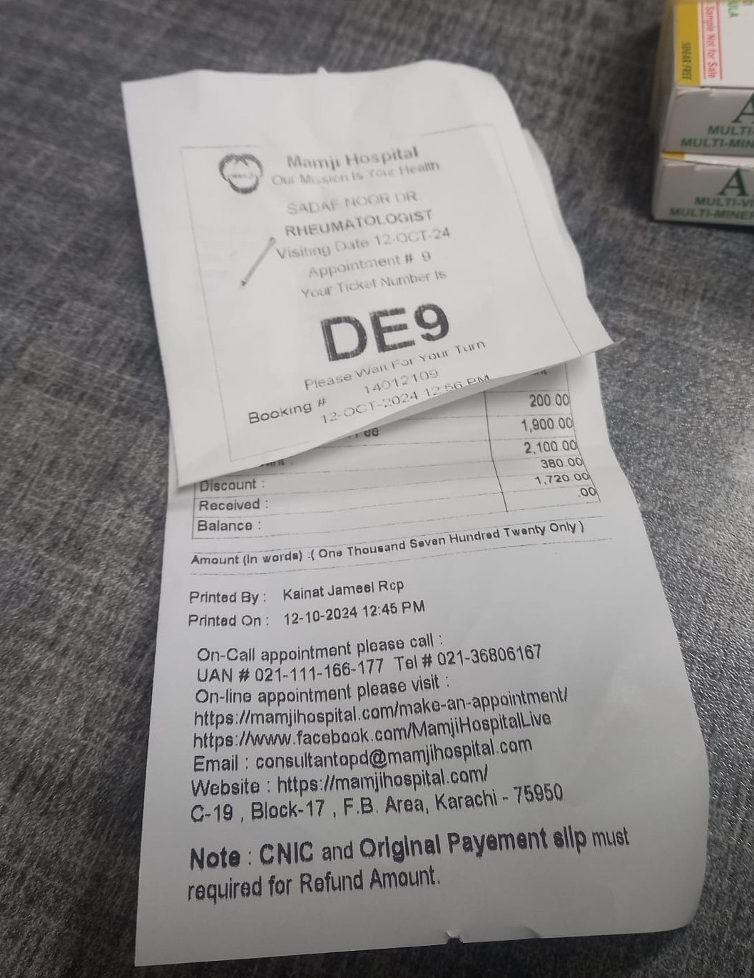

SUPPORT
In this chapter you have to attach system support contract

System Support Contract
This contract, dated Dec 31, 2024, was created by Sukaina Shoaib , Habiba Azfar , Syed Azhar , and Abdullah Danish
In consideration of the mutual promises and covenants in this contract, of which the receipt and sufficiency are hereby acknowledged, the Parties further agree to the terms as follows:

Services:
The Client hires the Company to provide software support services for the Hospital Management System.
The Company agrees to do the following services for the Client:
- Software Maintenance and Support: Perform necessary modifications to the application software, which includes hardware configuration changes and routine updates.
- Corrective Action: Address logical, coding, and design errors in the software system.
- Preventive Maintenance: Conduct precautionary measures to account for all potential problems to the software before they become operational faults.
- We are available to serve in all contexts, i.e., bug removal, extension, maintenance, and enhancement purposes, related to the Hospital Management System software application.

Terms and Conditions:
- This Contract will be effective starting Dec 31, 2024, and will continue in full force until its termination date, which is June 30, 2024 (Term).

Group Members Acknowledgment:
- Sukaina Shoaib
- Habiba Azfar
- Syed Azhar
- Abdullah Danish

CONCLUSIONS AND SUGGESTIONS FOR FUTURE WORK

The Hospital Management System (HMS) aims to revolutionize healthcare delivery by addressing key challenges in real-time communication, appointment management, and data accuracy. It provides a streamlined and user-friendly interface, enabling efficient scheduling of appointments, test bookings, and treatment updates, while fostering seamless collaboration among healthcare providers. By ensuring data accuracy and operational efficiency, the system improves patient care quality and hospital workflows.
Future suggestions for the HMS include integrating AI for automation in appointment scheduling and resource allocation, predictive analytics to manage patient loads and optimize resources, and telemedicine features to enable remote consultations. Enhanced data security measures will protect sensitive patient information, while mobile applications for patients will improve accessibility and engagement. Additionally, expanding the system's capabilities for multi-hospital networks will allow centralized management of resources across multiple facilities, ensuring scalability and adaptability to evolving healthcare demands. These advancements will make the HMS more robust, efficient, and future-ready.

REFERENCES

Conference Examples:
- [Joh18] John, P. and Smith, L. (2018) “Hospital Management System: A Case Study,” Proceedings of the International Conference on Healthcare Informatics, Boston, MA, 12-14 September, pp. 120-130.
- [For17] Forrester, K. (2017) “Designing Real-Time Hospital Management Systems,” Proceedings of the 5th International Conference on System Design, London, UK, 10-12 May, pp. 200-210.
Journal Examples: 3. [Ada20] Adams, R. and Cooper, T. (2020) "The Role of Real-Time Communication in Hospital Systems," Journal of Medical Informatics, vol. 28, no. 4, April, pp. 52-67. 4. [McC22] McCarthy, L. (2022) "Trends in Hospital Management Systems," HealthTech Journal, vol. 32, no. 1, January, pp. 14-29.
- Book Examples: 5. [Wit14] Whitten, J. and Bentley, L.D. (2014) System Analysis and Design Methods, 7th ed., Lonnie D. Bentley, Boston, MA.
- 6. [Som15] Somerville, I. (2015) Software Engineering, 9th ed., Ian Somerville, Boston, MA.
Website References:
7. [https://en.wikipedia.org/wiki/Hospital_management_system] - Wikipedia, “Hospital Management System,” https://en.wikipedia.org/wiki/Hospital_management_system, General overview of hospital management systems. 8. [https://www.healthit.gov/health-it-initiatives/health-it-and-health-information-exchange-hie] - HealthIT.gov, “Health IT and Health Information Exchange,” https://www.healthit.gov/health-it-initiatives/health-it-and-health-information-exchange-hie, Information on Health IT initiatives for hospital management. 9. [https://www.hospitals-management.com/] - Hospitals Management, “Hospital Management,” https://www.hospitals-management.com, Online resource for hospital management trends and technologies. 10. [https://www.softwareadvice.com/healthcare/hospital-management-software-comparison/] - Software Advice, “Hospital Management Software Comparison,” https://www.softwareadvice.com/healthcare/hospital-management-software-comparison/, Comparison of hospital management software solutions.

APPENDICES SHOULD APPEAR AFTER THE LIST OF REFERENCES

Appendices in a report are typically used to provide additional information or supporting documentation that is not essential to the main body of the report, but may be useful for readers who want to know more. Appendices are usually identified alphabetically, and they should follow the same format guidelines as the main body of the report. They may include things like primary source documents, business documents collected during the analysis phase, summary of progress reports, and questionnaires used in interviews or surveys

LIST OF SYMBOLS

List of UML notations that are used in object oriented analysis and design.
Table no 03:
Symbol | Name | Description
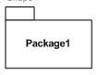 | Package | A collection of interfaces and classes.
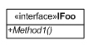 | Interface | Microsoft guidelines specify that interfaces should start with I. This graphic can also sometimes be used as an abstract class.
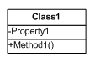 | Class | Properties or attributes sit at the top, methods or operations at the bottom. + indicates public and #indicates protected.
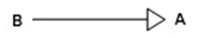 | Inheritance | B inherits from A. *is-a relationship
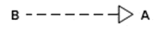 | Generalization | B implements A
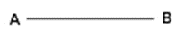 | Association | A and B call each other
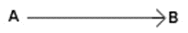 | One way Association | A can call B's properties/methods, but not vice versa.
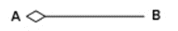 | Aggregation | A "has-a “instance of B.B can survive if A is disposed.
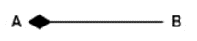 | Composition | A has an instance of B, B cannot exist without A.
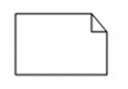 | A note | Some descriptive text attached to any item.

GLOSSARY
List of object oriented keywords with technical description that are used in the project.

UML Glossary:
Table no 04:
Object Oriented Keywords | Description
Single Responsibility Principle | A class changes for only one reason
Open/Closed Principle | A class should be open for extension, closed for editing
Liskov's Substitution Principle | Derived types should cleanly and easily replace base types
Interface Segregation Principle | Favor multiple single-purpose interfaces over composite
Dependency Inversion Principle | Concrete classes depend on abstractions, not vice-versa
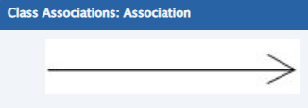 | Two objects have some sort of relationship to each other.
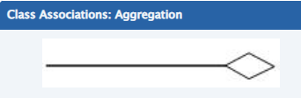 | An association where one object has-a (owns a) different object.
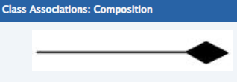 | An aggregation with dependency - objects are mutually destroyed/created.
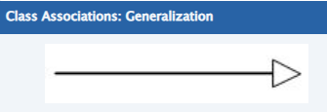 | "Is-A" relationship (inheritance).
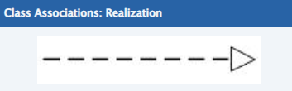 | One class implements behavior that is abstractly defined in another class.
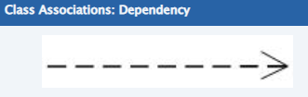 | One class weakly depends on another.
 | Only inside the same class instance
  Private
Protected | Inside same or derived class instances
Public | All other classes linking/referencing the class
Internal | Only other classes in the same assembly
Protected Internal | All classes in same assembly, or derived classes in other assembly
Static | Accessible on the class itself (can combine with other accessors)

INDEX
It should be generated by MS Word.

Go to insert -> reference -> index and tables

academic, 6
supervisor, 6

Table of Contents
INTRODUCTION AND OVERVIEW: 7
BACKGROUND 8
AIM AND STATEMENT OF PROBLEM 8
METHODS, ASSUMPTIONS, AND PROCEDURES 9
AVAILABLE RELEVANT SOLUTIONS AND EVALUATION 10
ANALYSIS AND DESIGN 11
FOR J = 1 TO NO. OF USE CASES 11
NEXT 11
USE CASE NARRATION: 74
SUPPORT 79
CONCLUSIONS AND SUGGESTIONS FOR FUTURE WORK 81
REFERENCES 82
CONFERENCE EXAMPLE 82
BOOK EXAMPLE 82
WEBSITE REFERENCE 82
APPENDICES SHOULD APPEAR AFTER THE LIST OF REFERENCES 83
LIST OF SYMBOLS 84
GLOSSARY 86
INDEX 88

ADDITIONAL FORMATTING INSTRUCTIONS
The report should be written in 12 point Times or Times New Roman, single spaced, with a .5” lead-in for each paragraph. Paragraphs should be fully justified. The report should have 1” margins on the top, bottom, left, and right sides. Page numbers should appear at the bottom of each page, centered on the page. Do not place a number on the cover or title page. Sections should be numbered consecutively; subsections are numbered consecutively within each section. Section numbers and subsection numbers are left justified and in bold. Diagrams and figures should be in imported JPEG format. Diagrams and figures should be numbered consecutively throughout the report. Tables should be centered on the page and use a 9 – 14 point type size.

